Family Rights Group logo
50 years helping families and children

Advice and policy briefing

From Family Rights Group’s Advice and Advocacy Service

Quarter 2, 2024-25

This briefing is published in Family Rights Group’s 50th year. Our expertise in both law and social work practice underpins our Advice and Advocacy Service - the only free national specialist advice service available to parents, relatives and kinship carers involved with or needing the support of children’s services.

The purpose of the briefing is to share insights from the work of our Advice and Advocacy service in July to September 2024. It offers a snapshot of the issues facing parents, relatives and kinship carers, and spotlights the key themes encountered by our advisers over the quarter.

### Contents

* Advice and Advocacy Service - key data
* Spotlight themes:
  + Kinship care – access to support
  + [The offer of a family group conference](https://amily)
  + Child protection conferences – poor engagement with families
* Demand for our Advice and Advocacy Service

# Advice and Advocacy Service - key data

July to September 2024

### How many people viewed our online resources:



### How many advice queries, including calls, we responded to:

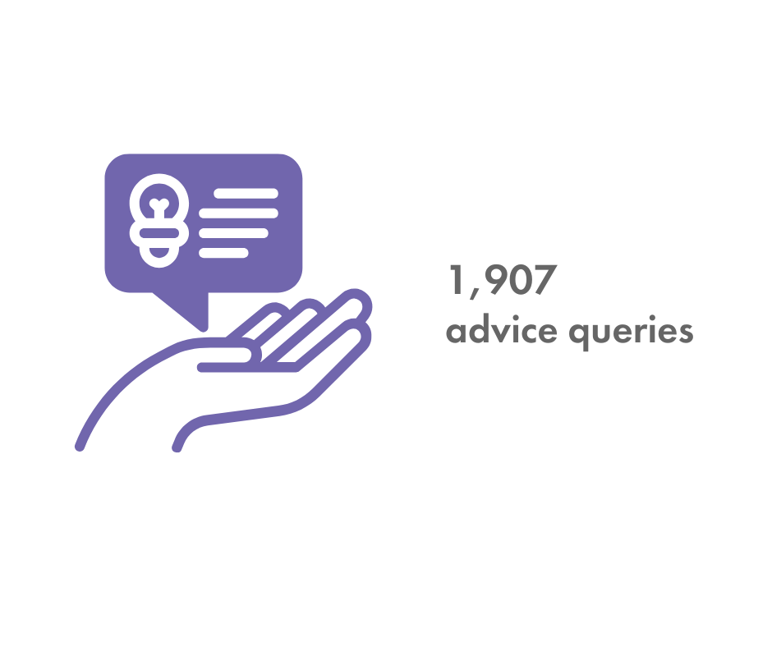

### 6% forum posts 21% Advice emails 6% Webchat 67% Adviceline callsHow people contacted us who received advice:

# Spotlight themes

## Kinship care – access to support

Kinship Care Week took place during this quarter. The week recognises the happy moments, challenges, and unique stories of kinship families. However, many enquiries to our Advice and Advocacy Service from kinship carers are about the challenges they face, including the barriers to accessing what limited support is available.

Whether a kinship carer is entitled to financial support depends on varying factors, not least whether there is a legal order in place and whether the children are currently or have previously been looked after. This means that in many situations whether and how much financial support is provided to kinship families is at the discretion of local authorities. It is also why it is so critical that prospective kinship carers get early independent specialist advice because the ramifications of not understanding their legal rights and options can be significant.

Below we provide a data snapshot of the 405 kinship carers who received advice from the Advice and Advocacy Service in July to September 2024.

#### The age range of kinship carers who we advised:

A graph showing the age range of kinship carers who contacted us for advice:
18-24 years old 1%
25-34 years old 7%
35-44 years old 20%
45-54 years old 29%
55-64 years old 26%
65-74 years old 14%
75 years or older 3%

#### The ethnicity of kinship carers who we advised:

A graph showing the ethnicity of kinship carers who contacted us for advice and gave us their data:
Asian or Asian British 3%
Black or Black British 9%
Mixed heritage 2%
Other 1%
White 85%

### Calls from kinship carers

A grandmother whose young grandson had been living with her for several months, called us. She was caring for her grandson because her daughter had been arrested for child neglect due to alcohol abuse. The grandmother explained that she is happy to look after her grandson but that she has received no support. She had to go down to part-time hours to be able to take and pick up her grandson from school. Her husband also had to change his work shifts to care for their grandson. This has affected their income and impacted their pensions.

Children’s services were clear that the child’s mother was not in a position to care for her son. They said that the child was safe with the grandmother and that she should seek legal advice about formalising the arrangement, but they did not offer help to secure such legal advice.

Our adviser explained what support children’s services could have offered to the grandmother and her grandson, at the same time as putting a structure and timescale around support and changes required by the mother. We set out the various legal arrangements that could be in place for her grandson to continue to live with her, temporarily or long term and explained the differences between them, including implications in terms of entitlement to support.

#### The type of disability experienced by kinship carers who we advised:

A chart showing the type of disability experienced by kinship carers who contacted us for advice and provided us with the information:
Yes - mental health 9%
Yes - physical disability 33%
Yes - deaf/ hearing loss 2%
Yes - learning disability 2%
Yes - neurodiverse 17%
Yes - multiple disabilities 7%
Yes - other type of disability 30%

### How lack of support impacts kinship carers

The experience of the kinship families we talk to is that the local authority has often not provided them with clear information as to their rights and options. Sometimes local authorities wrongly claim, despite placing a child with them, that it is a private arrangement, and thus claim that financial support is discretionary, as opposed to complying with their duties. This often means that children and their kinship families do not get the support they need and would otherwise be entitled to.

Evidence from our Advice and Advocacy Service shows that the current system of financial support for kinship carers:

* lacks transparency and fairness and leads to inconsistencies and injustices in how allowances are paid,
* leads to a lack of support for children and their relatives or friends who put themselves forward as kinship carer; and
* puts pressures and strains on kinship care families, risking breakdown of arrangements, worse outcomes for children, and escalating costs for local authorities.

### To ensure children and families in kinship care arrangements get the support they need, Family Rights Group proposes:

* A definition of kinship care in law.
* A duty on local authorities to develop and publish a local offer for kinship families.
* A legal right for families to be offered a family group conference before social workers consider going to court to remove their children.
* A right to paid employment leave for kinship carers.

Family Rights Group is calling for these measures to support kinship families as part of our [Act for Kinship Care campaign](https://frg.org.uk/policy-and-campaigns/kinship-care/act-for-kinship-care/). We are very pleased that elements of these measures are included in the Children’s Wellbeing and Schools Bill – see our [analysis of the Bill](https://frg.org.uk/policy-and-campaigns/childrens-wellbeing-and-schools-bill/).  
  
We are delighted that the Bill includes a definition of kinship care. This can be the foundation for an effective and fair system of financial and practical support for children and kinship carers. We see the Children’s Wellbeing Bill and the Employment Rights Bill and review of parental leave as a once in a generation opportunity to transform support for kinship families. Alongside investment in the financial, practical, and emotional support children and families need.

## The offer of a family group conference

The family group conference approach originated in New Zealand, where it is embedded in the legal framework. Family Rights Group has been at the forefront of the development and introduction of family group conferences in the United Kingdom. Research shows that family group conferences help keep children out of the care system and safely in their family.[1] Yet our Advice and Advocacy Service regularly advises families who have never heard of a family group conference, or have not been offered one early enough.

### Calls from families

A mother contacted Family Rights Group about her baby who had been removed from her and the father’s care due to concerns about alcohol and substance misuse. The baby had been placed in foster care, care proceedings were underway, and the local authority were planning adoption. The parents had not been offered a family group conference.

Our adviser reassured the mother that final decisions had not yet been made, and that it is ultimately the court’s decision about whether her baby will be adopted. We encouraged her to continue working in partnership with children’s services.

We explained her right to request a family group conference, which could be used to identify support from her family and friends’ network to enable her baby to remain at home with her or be cared for by a member of her family.

### Too many families not being offered a family group conference

Family group conferences help families to lead decision-making and make a safe plan for their child. They can help to identify support for parents within the wider family and friends’ network. For children who cannot remain with their parents they can help to identify kinship carers within their network.

Failing to offer a family group conference, offering one too late, or not meeting family group conference quality standards runs the risk of missed opportunities to maintain relationships, build on family strengths, support parents, and ultimately keep children out of the care system.

### To ensure families are involved and supported to take part in effective family group conferences, Family Rights Group proposes:

* **A legal right to a family group conference when there are concerns about the care or protection of a child.**

It is clear from many enquiries to our Advice and Advocacy Service that many families could benefit from a family group conference (FGC). [Recent research](https://foundations.org.uk/our-work/publications/family-group-conferencing-at-pre-proceedings-stage/) into FGCs at pre-proceedings stage in England found that children who were referred for an FGC were less likely to go to court, less likely to go into the care system, and spent less time in care when they became looked after, compared to those who were not, a year later. A new national offer of family group decision making is at the forefront of the Children’s Wellbeing and Schools Bill – we strongly welcome this but think it could be strengthened. See our [analysis of the Bill](https://frg.org.uk/policy-and-campaigns/childrens-wellbeing-and-schools-bill/).

* **A right to independent legal advice and advocacy.**

Early information and specialist advice, from both legal aid providers and the voluntary advice sector, helps prevent difficulties from escalating and can avert court proceedings. Independent specialist advice allows families to understand their rights and options and to work in partnership with professionals. Family Rights Group is concerned about the ability of families to access our Advice and Advocacy Service when we can only answer 4 in 10 calls.

* **Family involvement in service design and policy development.**

Professors Morris and Featherstone’s 2018 [‘Stepping Up, Stepping Down’](https://frg.org.uk/wp-content/uploads/2020/10/Stepping-Up-Stepping-Down-Report.pdf) report concluded that families had a significant – untapped – knowledge about policy and practice that had the potential to beneficially reform services from the ‘bottom up’.

## Child protection conferences – poor engagement with families

Family Rights Group hears about many examples of poor communication and lack of children’s services working in partnership with families when there are child protection concerns.

Below we provide a data snapshot of enquiries relating to child protection in July to September 2024.

### Who we advised about child protection:

A pie chart showing who contacted us for advice about child protection: 
Wider Family 18%
Mothers 59%
Fathers 21%
Practitioners 2%

### A graph showing the top five underlying reasons people contact us for advice about child protection: Domestic abuse 37% Non accidental injury 11% Parental mental ill-health 17% Parental substance misuse 14% Sex offence/ alleged sex offence 20%The top five underlying reasons people contact us for advice about child protection:

### Calls from families

A mother told us that she had an initial child protection conference scheduled for the day she was due to give birth.

The mother attended the conference by telephone from the hospital, at which a decision was made that a child protection plan was necessary.

The mother explained that no support was put in place for the family. The mother had to take a taxi home with her newborn. She told us that she had to break her safety plan by allowing the father to deliver some shopping to the family home as she did not have the things she needed. This led to children’s services considering taking the matter to court. But the mother said she had not received a letter before proceedings.

The mother did not understand why children’s services became involved when they did. The mother also told us that she did not know how to work with children’s services.

#### How Family Rights Group helped this mother

Our adviser acknowledged what a difficult situation the mother was in, as well as her efforts to attend the initial conference despite having just given birth.

We answered her questions, and explained why children’s services may be concerned about her baby. We discussed which elements of the process appeared to have been handled inappropriately by children’s services. We emphasised that children’s services should always try to work with a family to avoid escalating matters to court, before formally issuing care proceedings. We told the mother that she could consider making a formal complaint, and explained how. We also encouraged her to seek support for herself from other specialist organisations.

A father called the Family Rights Group advice line three working days before a child protection conference was due to take place – he had not yet received the conference report. The father was also distressed by an unannounced visit by a social work manager to the family home at 9.30 pm the previous evening.

The father described how children’s services had become involved with the family following an anonymous referral that stated that the father had been drinking alcohol on the drive to school to pick up his children.

Our adviser explained to the father that it is good practice for the child protection report to be shared with the parent prior to the conference. We advised on how to request a copy of the report and what to do if he does not get one in advance of the conference.

We spoke about the potential reason for the unannounced home visit, especially considering that the anonymous referral was related to alcohol misuse. We explained that he should have been told that unannounced visits may happen as part of safeguarding and ongoing enquiries.

### Why partnership working at child protection conferences matters

Poor engagement with families around child protection conferences can result in parents not understanding their rights and options, barriers to attending the conference, reports not being shared with parents, and parents being unable to prepare, correct inaccuracies, put their own views forward or secure legal advice.

Too often child protection conferences take place at short notice, sometimes in the case of newborn babies, whilst the mother is still in hospital.

This lack of engagement and partnership working not only leads to injustice but also poorer outcomes for families – missed opportunities to maintain relationships, provide support and build on families’ strengths.

### To ensure parents are properly engaged in the child protection conferences:

* [Born into Care best practice guidelines](https://www.nuffieldfjo.org.uk/resource/born-into-care-best-practice-guidelines-and-other-resources) should be embedded and followed.
* Family Rights Group’s [Mutual Expectations charter](https://frg.org.uk/policy-and-campaigns/families-voices/mutual-expectations/) on effective, mutually respectful partnership working between practitioners and families should be adopted.
* Families should have a right to independent legal advice and advocacy, toallow them to understand their rights and options and to work in partnership with social work professionals.

# What people say about our Advice and Advocacy Service

“There are no words that would express my gratitude to you for helping us so much. I will follow those links and hopefully we will manage to get back on track in no time. Thank you so so so much.”

* + Mother who called the advice line and also received detailed follow up advice by email

“Thank you so much for speaking to me on Friday and for the advice and the template letters. It has all been incredibly helpful. I spoke to children's services on Friday after I spoke to you and they have arranged a case review on Monday. I hope that they will therefore reassess the current private arrangement. If not, I will adapt the letter and send it on as soon as possible. Thank you again.”

* + Aunt who received detailed advice via the advice line and follow up email. Children’s services asked her to care for her nephews but claimed it was a private arrangement. Since using our template letter she has been assessed as a foster carer but has not been awarded the correct amount of fostering allowance, so we have provided her with additional advice via email.

“The website on kinship care was very useful and we might take this route in the future. Thank you also for all the links and information- has been really helpful. Thank you. I will keep your details for future use if needed.”

* + A family friend, who sought advice about caring for their daughter’s friend, via the advice enquiry form

# Demand for our Advice and Advocacy Service

Currently we are unable to meet the demand for our service, and yet demand is growing:

* The numbers of people visiting our online information and resources is rising, with an increase of 90,000 visitors this year.
* We are only able to answer the calls from 4 in 10 callers to our advice line.
* We have expanded our digital offer and demand for digital advice has grown. This year, 2023-24, we responded to 1,500 more digital enquiries than last year.

Our latest evaluation demonstrates that between April 2022 and March 2024, £23 was saved in public spending for every £1 invested in our advice line. This equates to over £24.5 million over the last two years.

# Was this briefing useful?

Family Rights Group Advice and Advocacy Service provides us with evidence and insight into the issues faced by families and kinship carers, and their interactions with the child welfare system. We work to amplify children’s and families’ voices and put them at the centre of decision making.

We hope this briefing is useful to you in your work. Please feel free to tell us what was helpful and what you might like to see in future briefings.

### Contact:

|  |
| --- |
| * Jordan Hall, Head of Public Affairs - [jhall@frg.org.uk](mailto:jhall@frg.org.uk) |

© 2025 Family Rights Group

FRG Limited, Established in 1974.

Company Registration No. 2702928. Charity No. 1015665 (England and Wales). SC047042 (Scotland). VAT Registration No: 122 8302 49.

1. Taylor, S., Blackshaw, E., Lawrence, H., Stern, D., Gilbert, L., & Raghoo, N. (2023). Randomised controlled trial of family group conferencing at pre-proceedings stage. *Foundations: What Works for Children’s Social Care. Available online at: https://foundations. org. uk/wp-content/uploads/2023/06/Randomised-controlled-trial-family-group-conferencing. pdf (accessed June 16, 2023)*.